Steps to connect to the Mr. Lau’s Drop Folder on a mac—

On the Finder Screen (if not sure, just click on the desktop, the upper left should say “Finder” next to the apple icon) | 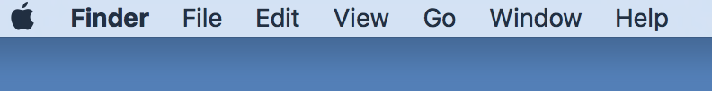
Go to [GO]  Then [Connect to Server] | 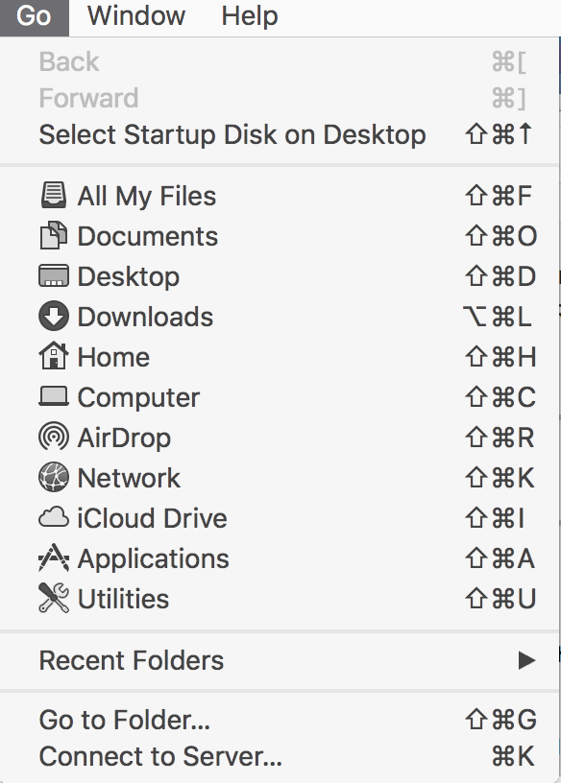
In the Server Address, input: smb://wkafile1  Click connect. | 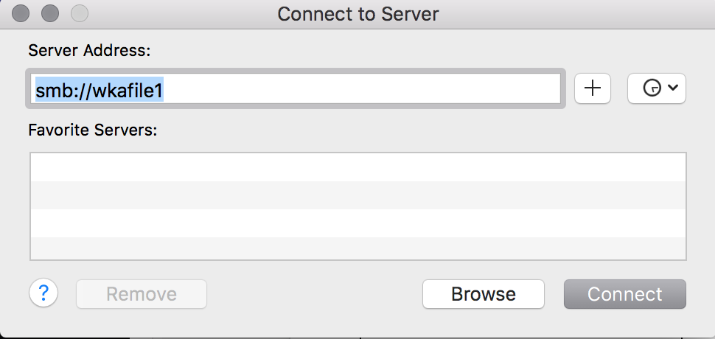
Then Navigate to—  Read_Drop>  Art>  Lau>  Your period.  Create a folder with your name and place your files in with your name and the assignment name. | 